OS - Experiment 2

Name: Kartik Jolapara Sapid: 60004200107

Div./Batch: B/B1 Branch: Computer Engineering

# AIM:

System calls for file manipulation.

## Problem Statement:

Try different file manipulation operations provided by linux

## pwd command

pwd, short for the print working directory, is a command that prints out the current working directory in a hierarchical order, beginning with the topmost root directory ( / ). To check your current working directory, simply invoke the pwd command as shown.

codingmickey@DESKTOP-DC7H32B:~ $ pwd

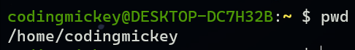

## 2. mkdir command

You might have wondered how we created the tutorials directory. Well, it’s pretty simple. To create a new directory use the mkdir (make directory) command as follows:

codingmickey@DESKTOP-DC7H32B:~ $ mkdir hiOS

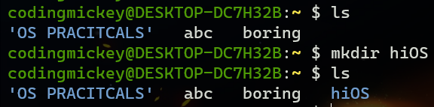

## 3. ls command

The ls command is a command used for listing existing files or folders in a directory. For example, to list all the contents in the home directory, we will run the command.

codingmickey@DESKTOP-DC7H32B:~ $ ls

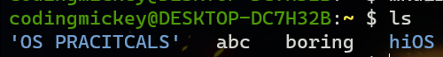

## 4. cd command

To change or navigate directories, use the cd command which is short for change directory.

For instance, to navigate to particular directory run the command:  
$ cd hiOS

To go a directory up append two dots or periods in the end.  
$ cd ..

To go back to the home directory run the cd command without any arguments.  
$ cd

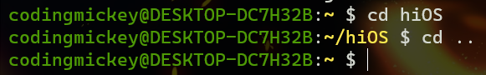

## 5. rmdir command

The rmdir command deletes an empty directory. For example, to delete or remove the tutorials directory, run the command:

codingmickey@DESKTOP-DC7H32B:~ $ rmdir hiOS

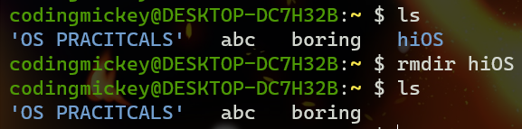

## 6. touch command

The touch command is used for creating simple files on a Linux system. To create a file, use the syntax: $ touch filename For example, to create a file1.txt file, run the command:

codingmickey@DESKTOP-DC7H32B:~ $ touch boring.txt

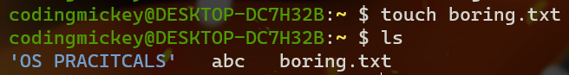

## 7. cat command

To view the contents of a file, use the cat command as follows:

codingmickey@DESKTOP-DC7H32B:~ $ cat fileName

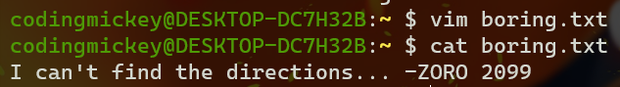

## 8. mv command

The mv command is quite a versatile command. Depending on how it is used, it can rename a file or move it from one location to another. To move the file, use the syntax below:

$ mv filename /path/to/destination/

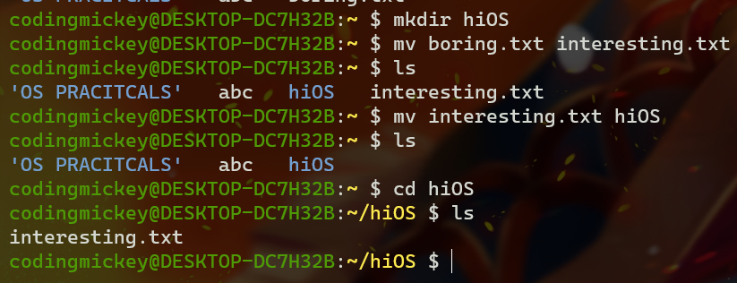

## 9. cp command

The cp command, short for copy, copies a file from one file location to another. Unlike the move command, the cp command retains the original file in its current location and makes a duplicate copy in a different directory. The syntax for copying a file is shown below.

$ cp /file/path /destination/path

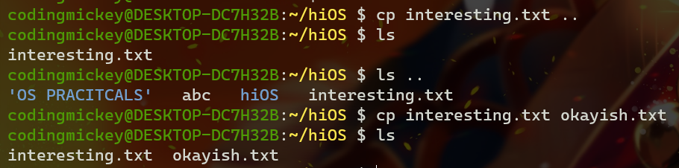

## 10. Deleting a file

Deleting a File rm command could be used to delete a file. It will remove the filename file from the directory.

$rm filename

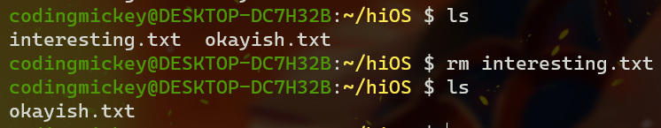

# Conclusion:

Thus, we studied various Linux commands.